BS Software Engineering
OPEN ENDED LAB (OEL)
COMPUTER NETWORKS



DEPARTMENT OF SOFTWARE ENGINEERING
FACULTY OF ENGINEERING & COMPUTING
NATIONAL UNIVERSITY OF MODERN LANGUAGES
ISLAMABAD
2024


NATIONAL UNIVERSITY OF MODERN LANGUAGES
FACULTY OF ENGINEERING AND COMPUTING
DEPARTMENT OF SOFTWARE ENGINEERING

Open Ended Lab (OEL)

Course : Computer Networks Credit Hours: (3+1)
Semester: 5th Total Marks: 15

OEL Title: Implementing VLANs on a Campus
OEL Level: 2
Objectives:
The purpose of the open-ended lab is to provide students with practical hands-on experience in configuring, securing, and managing a small-scale network setup.
Students will apply skills to:
- Design and Implement VLANs: Configure three VLANs on THREE switches for inter-VLAN-routing.
- Enable Inter-VLAN Routing: Set up a router to enable communication between VLANs.
- Enhance Network Security: Secure the switches and router by implementing best practices, including:
  - Securing console and VTY access.
  - Configuring passwords for privileged EXEC mode.
  - Securing Ethernet interfaces.
- Implement IP Addressing Using VLSM: Utilize a Class B network address starting with ‘172.x.0.0’ with a subnet mask of ‘255.255.0.0’ to subnet the network and assign appropriate IP ranges to each VLAN and the router interface.
Learning Objectives
By completing this lab, students will be able to demonstrate that they can:
- Understand VLAN Concepts:
  - Explain the purpose and advantages of VLANs.
  - Demonstrate the creation and assignment of VLANs on switches.
- Perform Inter-VLAN Routing:
  - Configure a router for inter-VLAN communication.
  - Understand the role of a router-on-a-stick configuration.
- Implement Network Security Measures:
  - Configure console, VTY, and privileged EXEC mode security on switches and routers.
  - Apply basic interface security measures to Fast-Ethernet ports.
- Apply Subnetting with VLSM:
  - Understand and apply Variable Length Subnet Masking (VLSM) to efficiently allocate IP addresses.
  - Use the provided “172.x.0.0” address and subnet mask “255.255.255.0” to assign IP ranges for VLANs and inter-VLAN routing. The Third Octat should represent the VLAN IP like 1, 100, or 200
- Integrate and Troubleshoot Network Components:
  - Connect and configure switches and a router in a real-world topology.
  - Troubleshoot connectivity issues between VLANs and within the network.
- Develop Problem-Solving Skills:
  - Analyze network requirements and devise a suitable configuration plan.
  - Apply critical thinking to address unexpected challenges in the network setup.
This lab not only reinforces technical and theoretical networking skills but also prepares students to design, secure, and subnet small-scale enterprise networks using VLSM for efficient IP address management.
Background Information:
This lab explores key networking concepts essential for designing, configuring, and securing small-scale enterprise networks. Students will work with Virtual Local Area Networks (VLANs) to logically segment a network, improving efficiency and security by grouping devices based on function rather than physical location.
Students will configure inter-VLAN routing using a router-on-a-stick method to enable communication between VLANs. The lab also emphasizes the application of IP addressing techniques, including Variable Length Subnet Masking (VLSM), to efficiently allocate IP ranges within a Class B network (172.x.0.0/16) tailored to student-specific roll numbers. Additionally, students will implement critical security measures such as securing console and VTY lines, applying passwords for privileged EXEC mode, and safeguarding Fast-Ethernet and Gigabit interfaces.
Through this practical activity, students will gain hands-on experience in network design, device configuration, and troubleshooting, equipping them with the foundational skills needed for managing enterprise-level networks.
Problem:
This lab presents students with a real-world networking scenario where they are tasked with designing, configuring, and securing a network for two departments located in separate buildings, "Ibne Rushd" and "Ghazali," which are 90 meters apart.
Each department has its own dedicated VLAN: VLAN 100 for the SE students and VLAN 200 for the IT students. The challenge involves configuring two switches, one in each building, to support the VLANs and connecting them through a trunk link. Students must also configure a router to enable inter-VLAN communication, ensuring the SE and IT students can share resources securely and effectively.
For IP addressing, students will utilize a Class B network address (`172.x.0.0/16`, where `x` corresponds to the last three digits of their roll number, if the three digits exceeds 254 use only last two digits) and apply Variable Length Subnet Masking (VLSM) to efficiently allocate IP subnets to VLANs and router interfaces.
In addition to configuration, students must secure the network by implementing best practices. This includes securing access to the console and VTY lines, setting passwords for privileged EXEC mode, and locking down Fast-Ethernet interfaces to prevent unauthorized access.
The open-ended nature of the problem allows students to approach the task creatively, design their network layout, determine the IP subnetting scheme, and apply security measures as they see fit. They will also need to troubleshoot any connectivity issues that arise during implementation, fostering problem-solving and critical-thinking skills.
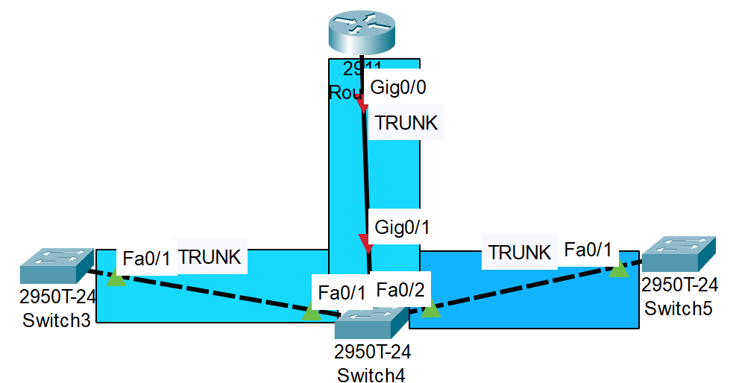
Requirements:
- Topology Constraints
- Design Topology as show in the figure.
- Annotate the topology for ease. Include your name, Roll No. and password.
- Color code your VLANs.

- Hardware Constraints
  - Use Router Model 2911
  - Use Switches Model 2950T –
    - A Gigabit ports should be used to connect middle layer 2 and 3 devices over a Trunk.
    - All switches first 2 ports will be used for Trunk to communicate between Layer 2 devices.
    - 8 ports for each VLAN should be dedicated on each Switch.
- Network Design Constraints:
  - Computers can communication using all VLANs (VLAN1, VLAN 100 for SE and VLAN 200 for IT) are allowed in the network.
  - The SE Lab should be designed for 20 students and IT Lab for 40 Student.
  - Each switch must be configured to support its respective VLANs and connected using a trunk link between the two buildings.
  - Inter-VLAN communication must be facilitated using a single router-on-a-stick configuration.
  - Native VLAN communication should be set to VLAN 100
- IP Addressing Constraints:
  - Students must use a sub-netted Class B network (172.x.0.0/24), where `x` is the last two digits of their roll number.
  - VLSM must be applied to efficiently allocate subnets for each VLANs and the router interface.
- Security Constraints:
  - Console and VTY access on switches and routers must be password-protected i.e., “<your five digit roll No>”.
  - Privileged EXEC mode must require a password on all network devices.
  - Fast Ethernet interfaces must be secured to prevent unauthorized access or misuse.
  - Give each Switch and a Router a daring MOTD of your own choice. Min 5, Max 10 Lines. Other than message it should show your Name, Roll No. and Department Name.
- Physical Constraints:
  - The three switches are located 90 meters apart in different buildings, and the connection must account for this physical distance.
  - Students must ensure proper cabling type and port configurations to establish trunk and access links.
- Equipment and Configuration Constraints:
  - Students can only use the defined switches and router for the network setup.
  - No additional devices or redundant configurations are allowed.
  - Configuration must adhere to standards and best practices for VLANs, IP addressing, and security.
- Time and Resource Constraints:
  - The lab must be completed within the allocated session time.
  - Students must work within the constraints of the provided lab environment, including physical devices, cabling, and access to configuration tools.
- Reporting Constraints:
  - Students are required to submit a formal report documenting their work on LMS.
  - The report must include headings for each configuration step, detailed explanations, and figures showing the network topology, VLAN configurations, IP addressing scheme, and device connectivity.
  - Report should have “Network Communication” section showing:
    - Pings to all VLANS.
    - Telnet to neighbor switches from any PC.
    - Pings to the designated VLAN’s Gateways.
  - Report should also have sections for “PC configurations”, “Router Configuration” and “Switch Configurations”, which include the following:
    - Running configurations.
    - VLAN briefs.
    - Trunk information.
  - The report should demonstrate an understanding of the design and configuration process, highlighting the security measures implemented and any troubleshooting steps taken.
  - For network simulation a PKT file must me submitted ensuring all the connectivity and security compliances.
HINT: Don’t forgot to save the configuration of switches and a router before submission, else student will be marked out of 50% marks.

****************Best of Luck and Happy Networking *******************

